**ABSTRACT**

In India a countless number of children are reported missing every year. Among the missing child cases a large percentage of children remain untraced. This paper presents a novel use of deep learning methodology for identifying the reported missing child from the photos of multitude of children available, with the help of face recognition. The public can upload photographs of suspicious child into a common portal with landmarks and remarks. The photo will be automatically compared with the registered photos of the missing child from the repository. Classification of the input child image is performed and photo with best match will be selected from the database of missing children. For this, a deep learning model is trained to correctly identify the missing child from the missing child image database provided, using the facial image uploaded by the public. The Convolutional Neural Network (CNN), a highly effective deep learning technique for image based applications is adopted here for face recognition. Face descriptors are extracted from the images using a pre-trained CNN model VGG-Face deep architecture. Compared with normal deep learning applications, our algorithm uses convolution network only as a high level feature extractor and the child recognition is done by the trained SVM classifier. Choosing the best performing CNN model for face recognition, VGG-Face and proper training of it results in a deep learning model invariant to noise, illumination, contrast, occlusion, image pose and age of the child and it outperforms earlier methods in face recognition based missing child identification. The classification performance achieved for child identification system is 99.41%. It was evaluated on 43 Child cases.

Keywords— Missing child identification, face recognition, deep learning, CNN, VGG-Face, Multi class SVM.

**INTRODUCTION**

* 1. OBJECTIVE OF THE PROJECT

The public is given provision to voluntarily take photographs of children in suspected situations and uploaded in that portal. Automatic searching of this photo among the missing child case images will be provided in the application. This supports the police officials to locate the child anywhere in India. When a child is found, the photograph at that time is matched against the images uploaded by the Police/guardian at the time of missing. Sometimes the child has been missing for a long time. This age gap reflects in the images since aging affects the shape of the face and texture of the skin. The feature discriminator invariant to aging effects has to be derived. This is the challenge in missing child identification compared to the other face recognition systems. Also facial appearance of child can vary due to changes in pose, orientation, illumination, occlusions, noise in background etc. The image taken by public may not be of good quality, as some of them may be captured from a distance without the knowledge of the child. A deep learning [1] architecture considering all these constrain is designed here

1.2 THE EXISTING SYSTEM

Mostly missing child cases are reported to the police. The child missing from one region may be found in another region or another state, for various reasons. So even if a child is found, it is difficult to identify him/her from the reported missing cases. A framework and methodology for developing an assistive tool for tracing missing child is described in this paper. An idea for maintaining a virtual space is proposed, such that the recent photographs of children given by parents at the time of reporting missing cases is saved in a repository.

**Disadvantages:**

Earliest methods for face recognition commonly used computer vision features such as HOG, LBP, SIFT, or SURF. However, features extracted using a CNN network for getting facial representations gives better performance in face recognition than handcrafted features.

1.3 THE PROPOSED SYSTEM

This paper presents a novel use of deep learning methodology for identifying the reported missing child from the photos of multitude of children available, with the help of face recognition. The public can upload photographs of suspicious child into a common portal with landmarks and remarks. The photo will be automatically compared with the registered photos of the missing child from the repository. Classification of the input child image is performed and photo with best match will be selected from the database of missing children. For this, a deep learning model is trained to correctly identify the missing child from the missing child image database provided, using the facial image uploaded by the public.

**Advantages:**

A deep learning architecture considering all these constrain is designed here.

The proposed system is comparatively an easy, inexpensive and reliable method compared to other biometrics like finger print and iris recognition systems.

Application Requirements

**Hardware Requirements**

* System : Pentium IV 2.4 GHz.
* Hard Disk : 40 GB.
* Floppy Drive : 1.44 Mb.
* Monitor : 15 VGA Colour.
* Mouse : Logitech.
* Ram : 512 Mb.

**Software Requirements**

* **Operating System:** Windows
* **Coding Language**: Python 3.7
* **DataBase**: Mysql

**Functional Requirements:**

In software engineering, a functional requirement defines a system or its component. It describes the functions a software must perform. A function is nothing but inputs, its behavior, and outputs. It can be a calculation, data manipulation, business process, user interaction, or any other specific functionality which defines what function a system is likely to perform.

Functional software requirements help you to capture the intended behavior of the system. This behavior may be expressed as functions, services or tasks or which system is required to perform.

1. ADMIN

2.USER

**Non- Functional Requirements:**

NON-FUNCTIONAL REQUIREMENT (NFR) specifies the quality attribute of a software system. They judge the software system based on Responsiveness, Usability, Security, Portability and other non-functional standards that are critical to the success of the software system. Example of nonfunctional requirement, *“how fast does the website load?”* Failing to meet non-functional requirements can result in systems that fail to satisfy user needs. Non- functional Requirements allows you to impose constraints or restrictions on the design of the system across the various agile backlogs. Example, the site should load in 3 seconds when the number of simultaneous users are> 10000. Description of non-functional requirements is just as critical as a functionalrequirement.

* Usabilityrequirement
* Serviceabilityrequirement
* Manageabilityrequirement
* Recoverabilityrequirement
* Securityrequirement
* Data Integrity requirement
* Capacityrequirement
* Availabilityrequirement
* Scalabilityrequirement
* Interoperabilityrequirement
* Reliabilityrequirement
* Maintainabilityrequirement
* Regulatoryrequirement
* Environmentalrequirement

**FLOW CHART:**

In the following sections the paper details the work flow for child matching methodology. The flow chart of the automatic child face identification methodology is as shown in Fig

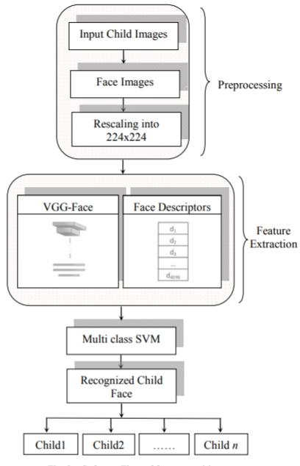

**UML DIAGRAMS:**

**USE CASE DIAGRAM:**

A use case diagram in the Unified Modeling Language (UML) is a type of behavioral diagram defined by and created from a Use-case analysis. Its purpose is to present a graphical overview of the functionality provided by a system in terms of actors, their goals (represented as use cases), and any dependencies between those use cases. The main purpose of a use case diagram is to show what system functions are performed for which actor. Roles of the actors in the system can be depicted.

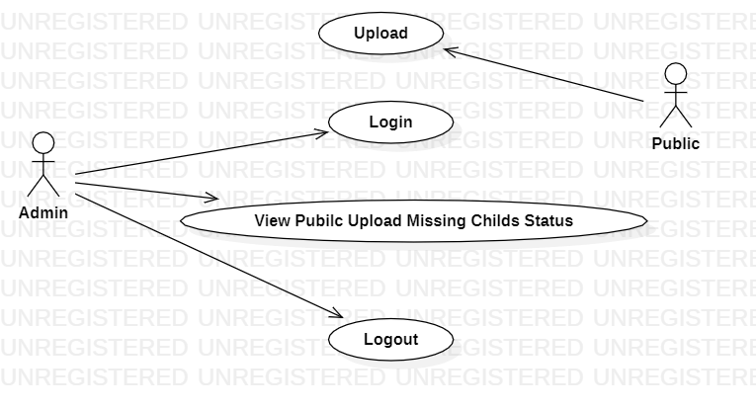

**CLASS DIAGRAM:**

In software engineering, a class diagram in the Unified Modeling Language (UML) is a type of static structure diagram that describes the structure of a system by showing the system's classes, their attributes, operations (or methods), and the relationships among the classes. It explains which class contains information.

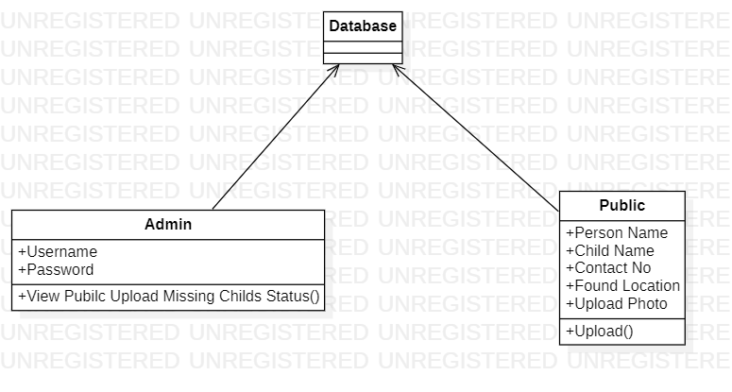

**SEQUENCE DIAGRAM:**

A sequence diagram in Unified Modeling Language (UML) is a kind of interaction diagram that shows how processes operate with one another and in what order. It is a construct of a Message Sequence Chart. Sequence diagrams are sometimes called event diagrams, event scenarios, and timing diagrams.

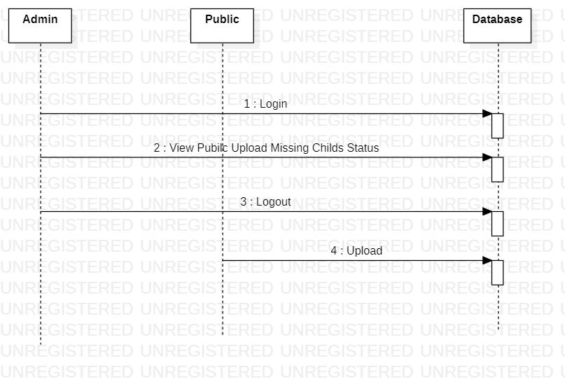

**ACTIVITY DIAGRAM:**

Activity diagrams are graphical representations of workflows of stepwise activities and actions with support for choice, iteration and concurrency. In the Unified Modeling Language, activity diagrams can be used to describe the business and operational step-by-step workflows of components in a system. An activity diagram shows the overall flow of control.

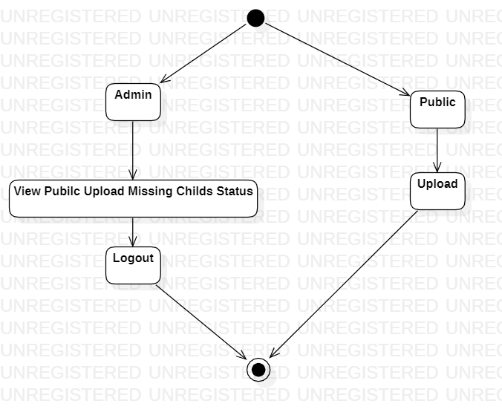

**ALGORITHM:**

**Convolutional Neural Network (ConvNet/CNN**):

A **Convolutional Neural Network (ConvNet/CNN)** is a Deep Learning algorithm which can take in an input image, assign importance (learnable weights and biases) to various aspects/objects in the image and be able to differentiate one from the other. The pre-processing required in a ConvNet is much lower as compared to other classification algorithms. While in primitive methods filters are hand-engineered, with enough training, ConvNets have the ability to learn these filters/characteristics.

The architecture of a ConvNet is analogous to that of the connectivity pattern of Neurons in the Human Brain and was inspired by the organization of the Visual Cortex. Individual neurons respond to stimuli only in a restricted region of the visual field known as the Receptive Field. A collection of such fields overlap to cover the entire visual area.

Image Dimensions = 5 (Height) x 5 (Breadth) x 1 (Number of channels, eg. RGB)

In the above demonstration, the green section resembles our **5x5x1 input image, I**. The element involved in carrying out the convolution operation in the first part of a Convolutional Layer is called the **Kernel/Filter, K**, represented in the color yellow. We have selected **K as a 3x3x1 matrix.**

**VGG Neural Networks:**

While previous derivatives of AlexNet focused on smaller window sizes and strides in the first convolutional layer, VGG addresses another very important aspect of CNNs: depth. Let’s go over the architecture of VGG:

* **Input.** VGG takes in a 224x224 pixel RGB image. For the ImageNet competition, the authors cropped out the center 224x224 patch in each image to keep the input image size consistent.
* **Convolutional Layers.**The convolutional layers in VGG use a very small receptive field (3x3, the smallest possible size that still captures left/right and up/down). There are also 1x1 convolution filters which act as a linear transformation of the input, which is followed by a ReLU unit. The convolution stride is fixed to 1 pixel so that the spatial resolution is preserved after convolution.
* **Fully-Connected Layers.** VGG has three fully-connected layers: the first two have 4096 channels each and the third has 1000 channels, 1 for each class.
* **Hidden Layers.**All of VGG’s hidden layers use ReLU (a huge innovation from AlexNet that cut training time). VGG does not generally use Local Response Normalization (LRN), as LRN increases memory consumption and training time with no particular increase in accuracy.

**The Difference.** VGG, while based off of AlexNet, has several differences that separates it from other competing models:

* Instead of using large receptive fields like AlexNet (11x11 with a stride of 4), VGG uses very small receptive fields (3x3 with a stride of 1). Because there are now three ReLU units instead of just one, the decision function is more discriminative. There are also fewer parameters (27 times the number of channels instead of AlexNet’s 49 times the number of channels).
* VGG incorporates 1x1 convolutional layers to make the decision function more non-linear without changing the receptive fields.
* The small-size convolution filters allows VGG to have a large number of weight layers; of course, more layers leads to improved performance. This isn’t an uncommon feature, though. GoogLeNet, another model that uses deep CNNs and small convolution filters, was also showed up in the 2014 ImageNet competition.

**SUPPORT VECTOR MACHINE(SVM)**

“Support Vector Machine” (SVM) is a supervised machine learning algorithm which can be used for both classification or regression challenges. However, it is mostly used in classification problems. In this algorithm, we plot each data item as a point in n-dimensional space (where n is number of features you have) with the value of each feature being the value of a particular coordinate. Then, we perform classification by finding the hyper-plane that differentiate the two classes very well (look at the below snapshot). The SVM algorithm is implemented in practice using a kernel. The learning of the hyperplane in linear SVM is done by transforming the problem using some linear algebra, which is out of the scope of this introduction to SVM. A powerful insight is that the linear SVM can be rephrased using the inner product of any two given observations, rather than the observations themselves. The inner product between two vectors is the sum of the multiplication of each pair of input values. For example, the inner product of the vectors [2, 3] and [5, 6] is 2*5 + 3*6 or 28. The equation for making a prediction for a new input using the dot product between the input (x) and each support vector (xi) is calculated as follows:

f(x) = B0 + sum(ai * (x,xi))

This is an equation that involves calculating the inner products of a new input vector (x) with all support vectors in training data. The coefficients B0 and ai (for each input) must be estimated from the training data by the learning algorithm.

**SCREENS**



In above screen public can click on ‘Public Upload Suspected Child’ link to get below page and to add missing child details

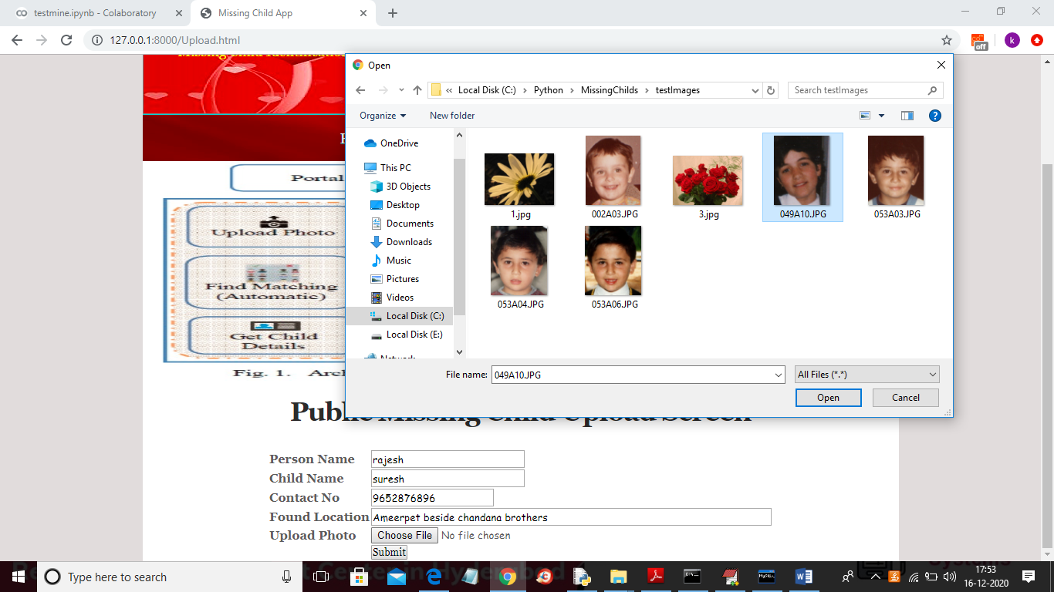

In above screen public will enter suspected child details and then upload photo and then click on ‘Submit’ button and to get below result



In above screen we can see child not found in missing DB and we can try with other image

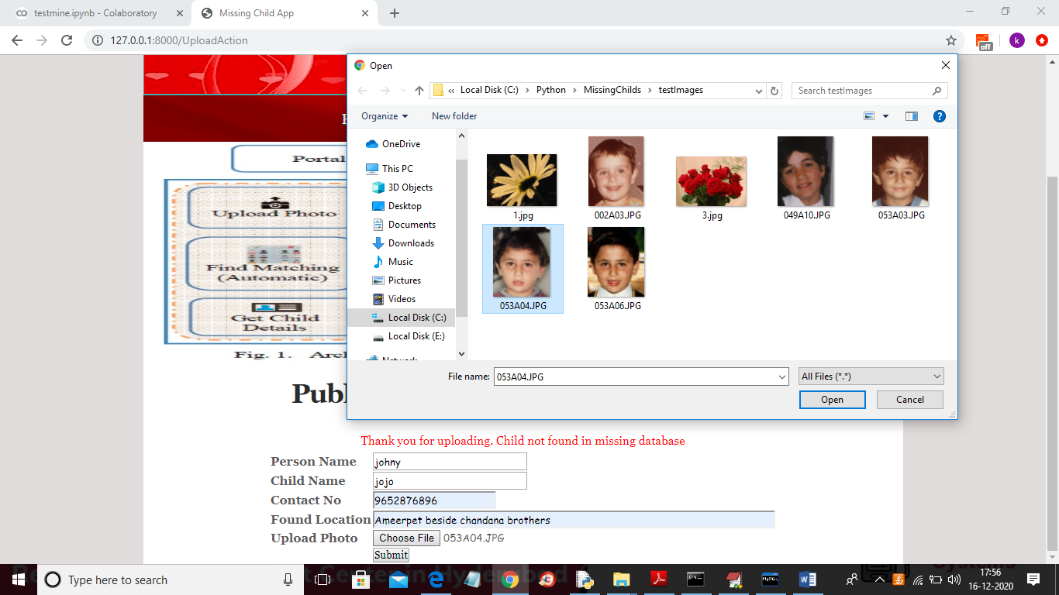

And below is the result for new above child details



In above screen uploaded child found in database and now click on ‘Official Login’ link to get below login screen

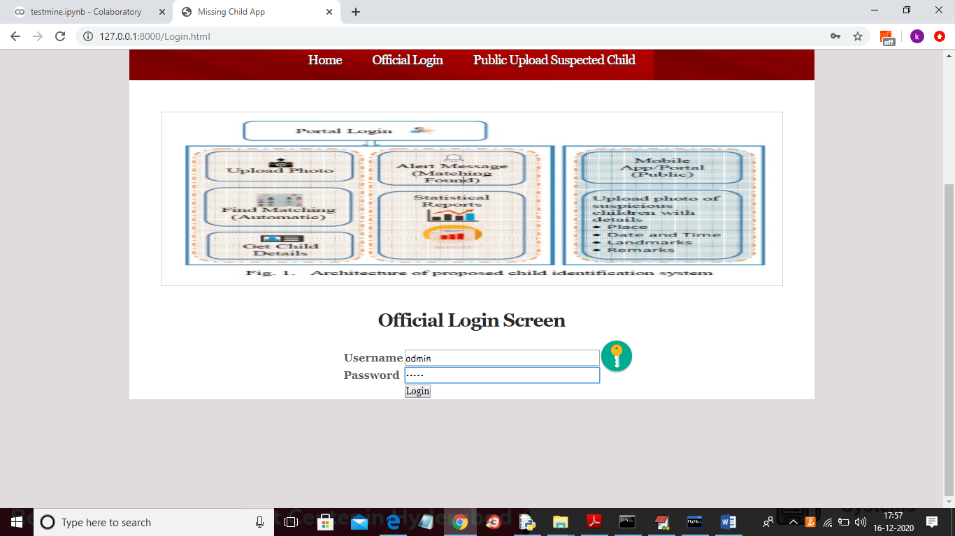

In above screen admin can login by entering username and password as ‘admin’ and ‘admin’ and after clicking on ‘Login’ button will get below screen

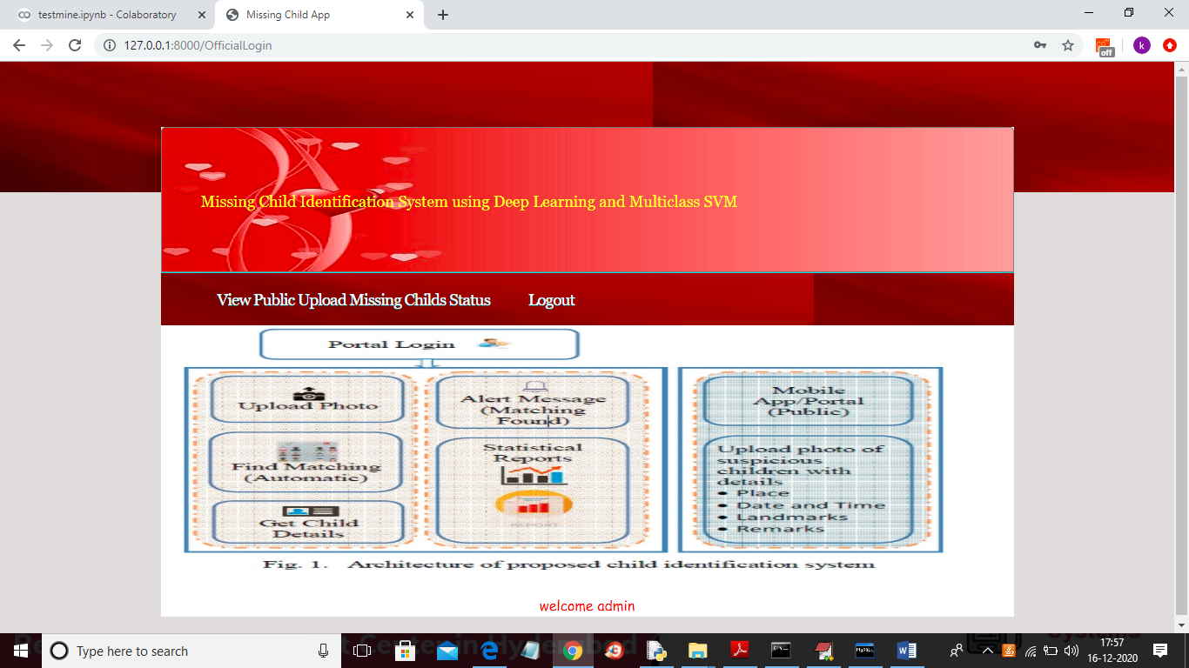

In above screen official can click on ‘View Public Upload Missing Childs Status’ link to view all uploads and its result done by public

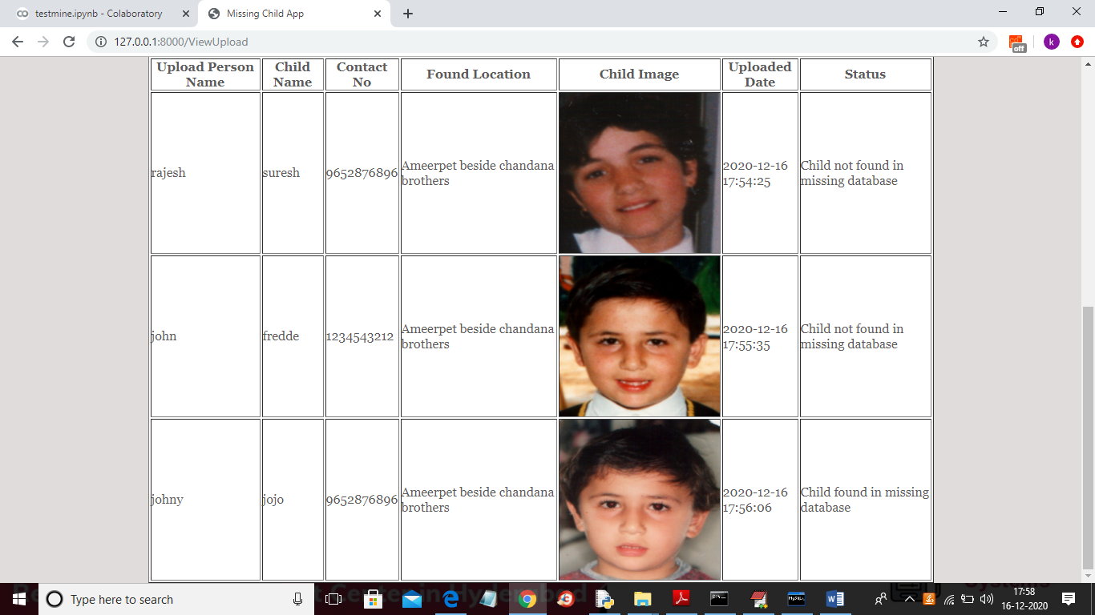

In above screen officials can see all details and then take action to find that child

Conclusion

A missing child identification system is proposed, which combines the powerful CNN based deep learning approach for feature extraction and support vector machine classifier for classification of different child categories. This system is evaluated with the deep learning model which is trained with feature representations of children faces. By discarding the softmax of the VGG-Face model and extracting CNN image features to train a multi class SVM, it was possible to achieve superior performance. Performance of the proposed system is tested using the photographs of children with different lighting conditions, noises and also images at different ages of children. The classification achieved a higher accuracy of 99.41% which shows that the proposed methodology of face recognition could be used for reliable missing children identification.

**REFERENCES**

1. Y. LeCun, Y. Bengio, and G. Hinton, "Deep learning", Nature, 521(7553):436–444, 2015.

2. O. Deniz, G. Bueno, J. Salido, and F. D. la Torre, "Face recognition using histograms of oriented gradients", Pattern Recognition Letters, 32(12):1598–1603, 2011.

3. C. Geng and X. Jiang, "Face recognition using sift features", IEEE International Conference on Image Processing(ICIP), 2009.

4. Rohit Satle, Vishnuprasad Poojary, John Abraham, Shilpa Wakode, "Missing child identification using face recognition system", International Journal of Advanced Engineering and Innovative Technology (IJAEIT), Volume 3 Issue 1 July - August 2016.

5.<https://en.wikipedia.org/wiki/FindFace>

6.<https://www.reuters.com/article/us-china-trafficking-apps/mobileapp-helps-china-recover-hundreds-of-missing-childrenidUSKBN15J0GU>

7.Simonyan, Karen and Andrew Zisserman, "Very deep convolutional networks for large-scale image recognition", International Conference on Learning Representations ( ICLR), April 2015.

8. O. M. Parkhi, A. Vedaldi, and A. Zisserman, "Deep Face Recognition," in British Machine Vision Conference, vol. 1, no. 3, pp. 1-12, 2015.

9. A. Vedaldi, and K. Lenc, "MatConvNet: Convolutional Neural Networks for MATLAB", ACM International Conference on Multimedia, Brisbane, October 2015.